

**République du Cameroun**

**Paix-Travail-Patrie**

**Republic of Cameroon**

**Peace-Work-Fatherland**

PkFokam institute of excellence

Dignity-Faith-Responsibility

**Faculty: Science and technology**

**Level: Sophomore II**

**Database System**

Project**: STOCK MANAGMENT SYSTEM**

Software Requirements Specification

**By:**

* **CAMARA SOULEYMANE**
* **TCHOUAMOU TCHAMDJOU Winnie**

**Supervisor:** **Mrs. TCHUANI**

March 2019

Contents

I. ABSTRACT 3

II. Objective 3

III. Requirements: 4

a. IMPORTANCE OF THE PROJECT 4

b. Overall description of the database 4

IV. MODULES DISCRIPTION 5

c. Registration Module of the System: 5

d. Home Page: 5

e. Product module Interface: 6

f. Supplier module Interface: 7

g. Order module interface: 8

h. Purchase module interface: 9

# ABSTRACT

The “STOCK MANAGEMENT SYSTEM” has been developed to override the problems prevailing from the manual system. This software is supported to eliminate and in some cases reduce the problems faced in the manual system. Moreover, this system is designed for the particular need of the company to carry out operations in a smooth and effective manner.

The application is reduced as much as possible to avoid errors while entering the data. No formal knowledge is needed for the user to use this system, thus proves it is user-friendly.

Our aim is to implement Stock Management System to show a tangible prove of what we acquired in PKFokam Institute of Excellence during Sophomore 2.

# Objective

The main goal is to put in place a computer software application that will be in charge of managing product and input/output operations in stock in an organization.

* The software should provide a friendly Graphical user interface (GUI).
* The Database should provide three access level:
* The Database Administrator responsible of database maintain and add a new naïve user.
* The Stock Manager, responsible of daily record of movement in stock and purchase transaction.
* The seller, responsible of sale’s operation; he is the one who make order.
* It should perform the basic CRUD functionalities; that is Create, Request, Update, and Delete a product, an order, a purchase or a supplier in the organization.
* It should prompt a login frame whenever the program is opened or run.
* It should collect all data entered by the administrator about entities and store it in a database.
* It should be able to load all the information from the database whenever the program is opened.
* It should be easy to maintain which means modification or an extension of the functions and database.
* It should provide searching facilities based on the name of product, supplier, customer and also the date whenever we add, update or delete a product, an order, a purchase or a supplier respectively.
* It should provide daily report of transaction in stock (input, output).
* It should enhance correctness and reduce man power.
* It should be easy to use.

# Requirements:

## IMPORTANCE OF THE PROJECT

* Facilitate the management of stock in a company.
* Maintain a database for all your current operations in stock.
* Increase the efficiency of the administrator by avoiding loss of time in searching product or supplier information because with this application, he would only enter a part of the name of the product or supplier and everything will be display with a click.
* Favors a better Expense Management since with the Stock Management System, all the expenses needed for papers, ink and folders are avoided since all is computed directly.

## Overall description of the database

Consider the **STOCK** database in which data is recorded about the Stock management. The data requirements are summarized as follows:

Each STOCK has one or more products store in it and also has one or more suppliers who can supply certain quantities of products. Then, an order involves zero or more products. Each product is concerned in one or more purchases.

* Products are identified by a unique product number, product name, product code, product category, product brand, product price and quantity. Each product can be supplied by one or more suppliers
* Suppliers are identified by a unique supplier number, first name, last name, contact, location, address and email. Each supplier
* Orders are identifier by a unique order number, customer first name, last name, date, product name, quantity and price. Each order is made by only one customer. And each order involves one or more product;
* Purchases are identified by a unique purchase number, first name and last name of supplier, date, product name, quantity, and price. Each purchase is concerned by zero or more product, and each purchase can also be delivered by one or more products.

# MODULES DISCRIPTION

## Registration Module of the System:

* + Admin registration(Operator of this Software)
  + User Registration(Stock User)

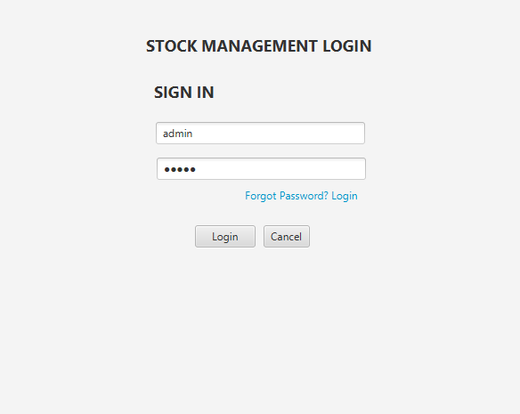

## Home Page:

When you click on home button, you will see some pictures or messages for welcoming users.

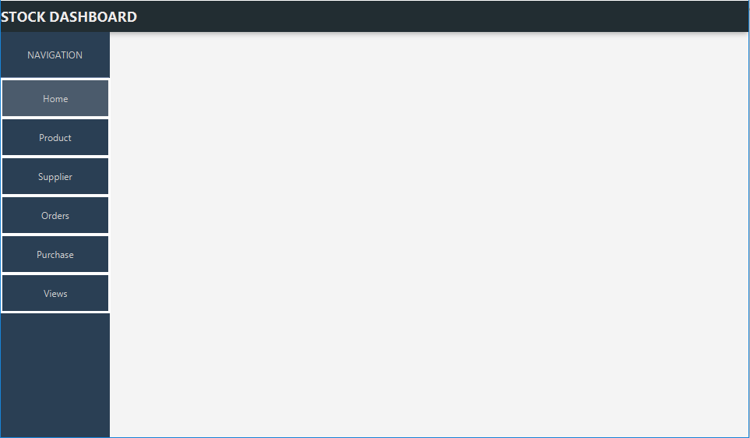

## Product module Interface:

When you click on the Product button, you have the following possibilities:

* + create a product and arrange it inside this table below,
  + updating a product
  + Viewing and searching product in the table
  + And deleting a product from the list.

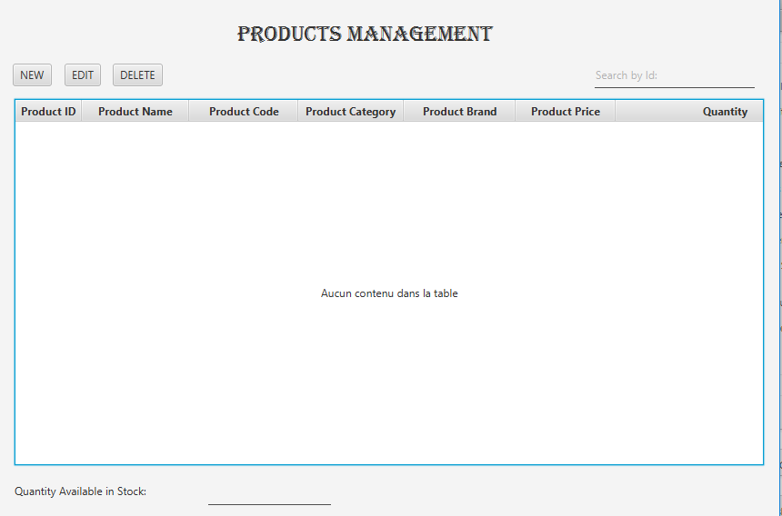

After each purchase or Order you have the possibilities to see the current state of the stock

## Supplier module Interface:

When you click on the Supplier button, the following possibilities are offered:

* create a supplier and arrange it inside this table below,
* updating a supplier in the table
* Viewing and searching supplier in the table
* And deleting a supplier from the list.

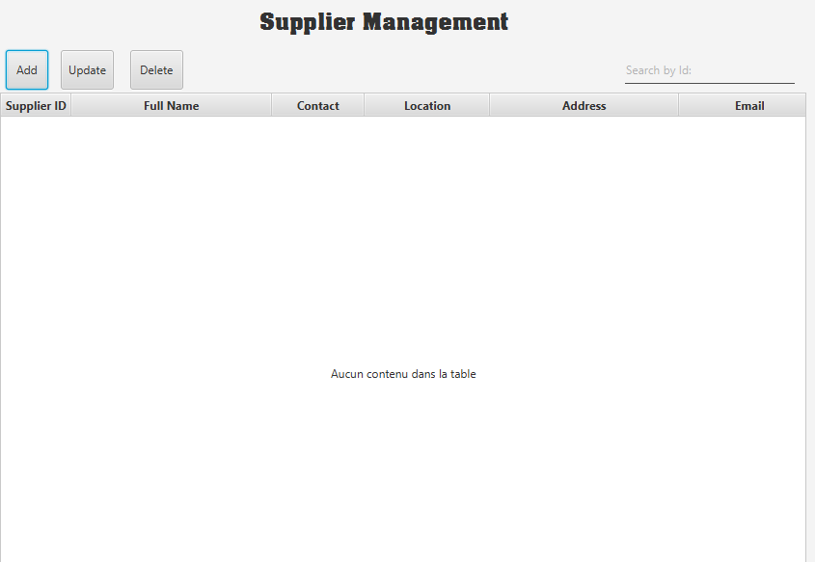

## Order module interface:

When you click on the Order button, the following possibilities are offered:

* Create an order by saving all the informations like his/her order number, name, date, list of products with their quantity, single and total price.

When you click on New, you enter the order number, customer name, date and you click again on add button to add many products for that customer.

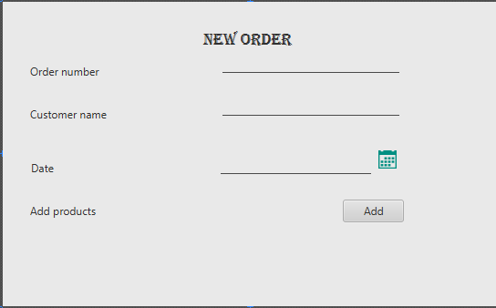

After clicking on add button, you will save the order for the particular customer in Order table.

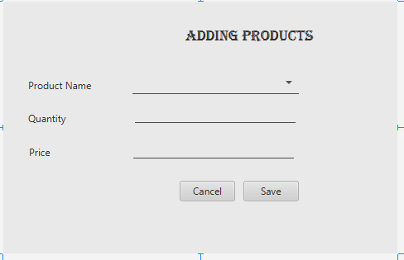

* updating an order in the Order table
* Viewing and searching all the orders by customer
* And deleting an order by clicking on Delete button

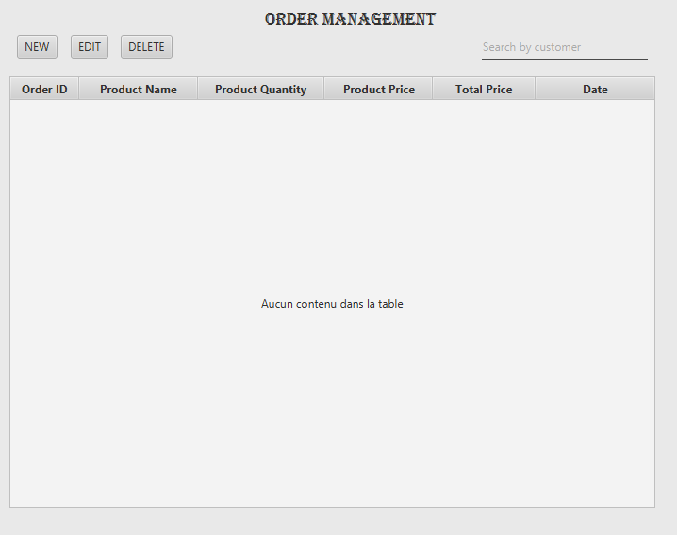

## Purchase module interface:

When you click on the Purchase button, the following possibilities are offered:

* Create a Purchase by saving all the information like purchase number, supplier name, date, list of products with their quantity, single and total price.

When you click on New, you enter the purchase number, supplier name, date and you click again on add button to add many products for that supplier.

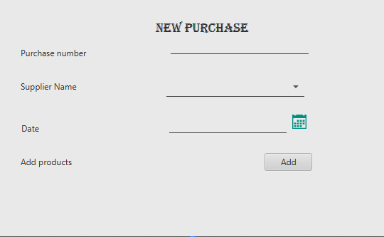

After clicking on add button, you will save the Purchase for the particular Supplier in Purchase table.

* updating a Purchase in purchase table
* Viewing and searching the products purchased by each supplier
* And delete a purchase

